The Game of Annexation: Team 16
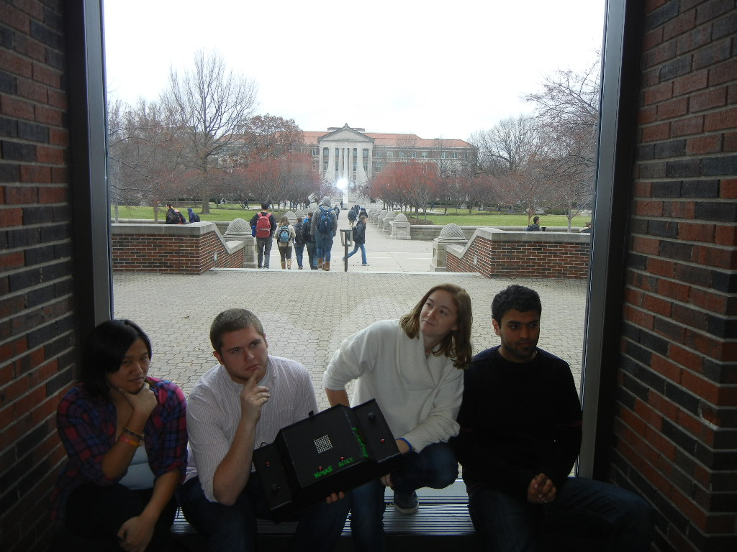
Team members, left to right are: Felise Goh, Clayton Brandt, Erin Rasmussen, and Apoorv Gaur.

Name | Class No. | Honors
Felise Goh | 4176-G | N
Apoorv Gaur | 4765-G | N
Clayton Brandt | 0032-B | N
Erin Rasmussen | 2364-R | N

MINI-PROJECT GRADING CRITERIA | Regular Students | Honors Contract Students
Originality, creativity, level of project difficulty | 20 | 10
Technical content, succinctness of report | 10 | 5
Writing style, professionalism, references/citations | 10 | 5
Project functionality demonstration | 20 | 10
Overall quality/integration of finished product | 10 | 5
Effective utilization of microcontroller resources | 10 | 5
Significance of individual contributions* | 20 | 10
PCB hardware schematic | N/A | 10
PCB top and bottom copper illustrations | N/A | 10
PCB functionality demonstration | N/A | 20
PCB written report | N/A | 10

*scores assigned to individual team members may vary

Scoring Multiplier:
1.0 | Excellent – among the very best projects/reports completed this semester
0.8 - 0.9 | Good – all requirements were amply satisfied
0.6 - 0.7 | Average – some areas for improvement, but all basic requirements were satisfied
0.4 - 0.5 | Below average – some basic requirements were not satisfied
0.1 - 0.3 | Poor – very few of the project requirements were satisfied

TABLE OF CONTENTS
1.0 Introduction | 1
2.0 Interface Design | 2
3.0 Peripheral Utilization | 3
4.0 Software Narrative | 4
5.0 Packaging Design | 5
6.0 Summary and Conclusions | 6
7.0 References | 7
Appendix A: Individual Contributions and Activity Logs | 8
Appendix B: Interface Schematic | 17
Appendix C: Software Flowcharts | 19
Appendix D: Packaging Design | 21
Appendix E: Honors Contract Deliverables (if applicable) | ?

- Introduction

Provide a brief functional description of your project and describe the role each team member played,

Length should be about one page.

Our project is based off of the game Othello, also known as Reversi or Annexation. We decided that we would make a digital version of the board game using an 8x8 LED matrix, two LCDs, four pushbuttons and two joysticks.
To provide a quick overview on how the game is played, the game starts with a square in the center with alternating colors (red and green). So if one can picture it in their head, the upper left and bottom right corners of the start box is green and the upper right and bottom left corners are red. Player one, which we have indicated as green, will start. Using a joystick, they will scroll through the matrix to pick where they want to place a piece. Player one can only place a piece where one of its existing pieces and the new piece sandwich a red piece, Player 2’s piece. Once the piece is set, pressing a pushbutton, the red pieces that are located between the new piece and any existing green pieces on the board will turn green. Then player 2 will take their turn. The game ends when all sixty-four spaces on the board have been filled and the winner will be the player with the most pieces on the board or if both players have no valid moves to make. Each player will have a LCD that will indicate if it is their turn, invalid moves meaning a player cannot place a chip where they have selected and who wins at the end. We also have a pushbutton to reset the game as well as a pushbutton that, when pressed, will display a Christmas tree to celebrate the holidays.
Felise Goh, Apoorv Gaur, Clayton Brandt and Erin Rasmussen are the TDP, peripheral, interface and software leaders respectively but we all played a part helping each other out when it came to debugging each other’s code. Apoorv worked on simultaneously producing output for two LCDs using the SPI peripheral. Clayton worked on interfacing the LED matrix, the two joysticks and the two pushbuttons together so that Erin, our software leader, could implement her code, originally written elsewhere, so our game could be played. Felise helped solder wires to the joysticks and other parts as well as write a majority of the documentation and took pictures for the poster. She also planned a majority of the group meetings.
- Interface Design

Describe any external interfaces utilized (e.g., switches, LEDs, sensors). Include your OrCAD schematic as Appendix B.

Length should be about one page.

As mentioned in the introduction, we interfaced many external components in order to get this project to work the way we want it to. These components include an 8x8 LED matrix, two joysticks, four pushbuttons and two LCDs.
The LED matrix relies on the SPI module to transfer its data to display on the matrix. The LED matrix has an SPI input and an SPI output but we decided as a group to only use the SPI output so the game board would be inputted to the LED matrix. We used a backpack controller, provided by Sparkfun, to help with the interfacing between the matrix and the microcontroller. There are five pins on the controller: two pins connected to power, one to ground, a computer select (CS) pin and a MOSI pin. Using the backpack controller datasheet, which is provided below as a reference, we figured out how to control the matrix. The CS pin, which is active low, controls the flow of input. When low, we are capable of changing the LED matrix by using a 64-bit array. We can change the color of a certain LED by changing the array: 0x01 for green, 0x02 for red, 0x03 for yellow and 0x00 for nothing. When the CS pin is high, the LED display on the matrix is frozen and we cannot send data to the matrix. Each time the CS pin is changed we must provide a 0.5 millisecond delay. The baud rate must also be 0x16 in order to allow the matrix to display our array.
The joysticks are controlled by two potentiometers each, meaning four in total. One potentiometer on one joystick controls the x direction and the other potentiometer can control the y direction. The joystick also has a switch and a pushbutton but we learned that the pushbutton resets the board. Therefore, we have used two separate pushbuttons to indicate a player placing a piece.
The LCDs are used to tell the players whose turn it is and if they can make a valid move. The interfacing is similar to what we did in lab except we have to incorporate the LCDs clock select signal to control the LCDs at separate times; in short, the clock signal acts like the CS pin in the matrix and allows us to control all three components using the SPI.

Microcontroller Resource Utilization

Describe how the microcontroller’s peripherals (ATD, SCI, SPI, TIM, PWM) as well as its other on-chip resources (RTI, SRAM, flash memory, etc.) were utilized, including the mode(s) in which they were programmed to operate. Provide rationale for the choices made.

Length should be about one page.

The peripherals used in the microcontroller for this project are the ATD and SPI; we are not incorporating any on-chip resources. The ATD is used to interface the two joysticks and the four pushbuttons; the SPI is used to control the LED matrix and the two LCDs as the game progresses.
The ATD is used for the joysticks and the four pushbuttons. The reason we use the ATD for the joysticks is because the joysticks are controlled by two potentiometers each, requiring us to use AN0-AN4 to read in the analog inputs of the four potentiometers in order for us to move the cursor on the LED matrix. We use the remaining four AN pins to implement our pushbuttons because the button, when pushed, generates a voltage of 5 volts. We use the AN pins to read in the voltage values and have the output act accordingly whether it be placing a chip during a game, resetting the game or display holiday cheer. In the ATD we use single conversion mode because we wanted to read each input individually outside of the other inputs for our components.
The SPI is used for implementing the two LCDs and the LED matrix into our mini project. The baud rate initialization for both LCD and LED matrix, however, are 0x10 and 0x16 respectively. When we attempted to use all three components with the same baud rate initialization, the LED matrix or the LCD could not read the data sent to it fast enough or was too slow and skewed our output. Since we only have one SPI and it must run three of our components we use the clock select for each component. So if the master, the microcontroller, is talking to one component, a slave, it will enable that slave’s clock select and output the according output without it affecting what is being displayed on the other two slaves. The master will then proceed to disable the component’s clock select, freezing the output.
Software Narrative

Describe what the software does and how it is organized/structured (i.e., event-driven, state machine, etc.). Submit your complete software listing on-line separately. Include a flowchart to document program structure in Appendix C.

Length should be about one page.

The software is structured as an event-driven because a lot of our software requires the pushing of a certain pushbutton, or a click of the joystick, to begin the next portion of our code. We have included two flowcharts in Appendix C: one flowchart that will display the logic of the software implementation of the game Othello itself and the other flowchart indicates how our hardware interacts with each other (e.g. a pushbutton will activate the opposite pair of joystick and pushbutton).
The hardware-to-software code is rather simple in complexity in terms of the implementation of the game. It consists of multiple if statements that control certain parts of the LED matrix. The joystick, for example, reads 0-5 volts with the center rest position being 2.5 volts. The potentiometer will read 0 volts if the joystick goes in one direction and 5 volts if the joystick is pushed the opposite direction. Once the input is read it will determine what direction the cursor LED will move. A pushbutton will be pressed to select the location the player wants to set the piece and the pressing of the pushbutton will also start the game software.
The software behind the game requires a set of if statements to check if the move is valid and to check eight directions: up, down, left, right, up-left, up-right, down-left, down-right to see if there are any opposing chips that are sandwiched between the new chip and the already existing chip. If there are, the opposing player’s chips will flip and the places will be owned by the player who set the new piece. The pushbutton will also switch turns so that the opposing player will go.
In terms of error checking, our software game implementation will check to see if the move the player makes is valid, if they are capable of making any valid moves and determines the winner and loser. All of these results will be displayed on two LCDs. The LCDs will also print the amount of chips each player has.
We also incorporated another pushbutton that, when pressed, will cause the LEDs to flash red and green as well as print a happy holidays greeting on the LEDs.
Packaging Design

Describe the packaging design for your project; include drawings/photos in Appendix D.

Length should be about one page.

Most of the design of the packaging of the project is displayed in Appendix D below. We originally wanted to have a Plexiglas box that would allow a person walking by to see the complexity of the wiring inside. Seeing as the software implementation took more time than we had originally anticipated, it took time away from creating our package for the mini project.
With our lack of power tools, we figured we would try and use a material that would be easily cut, to fit the LED matrix and the two LCDs but also look presentable; essentially, our team did not want a cardboard box as our packaging. We decided upon black foam board because it is easily cut with a box cutter and the black color provides a sleek shape to the package. To compensate for the material, we transformed the square box into a 3D trapezoidal shape. The top, highest level of the box contains our LED matrix along with our reset and Christmas push buttons. The box then slants downward and finishes on a lower level in where our joystick and select pushbuttons reside. We decided to place the LCDs on the slant angle because it would provide the user increased visibility to see what the LCD is printing out while still sitting down.
One side of the box is attached with Velcro, so we can pull down the side to display what is inside the box. The rest of the box is glued together and finally taped for aesthetic purposes.
In terms of dimensions, the height and width of the upper level of our package has been measured to include two breadboards side by side and is capable of housing a microcontroller inside. We also provided a little box and peephole to run the wire of the wall-wart from the microcontroller to the source. Wires connected to our components, pushbuttons and joysticks, have been soldered; other wires have been taped together using electrical tape to provide stability and extra insurance that no wire would come loose at any random time.
For aesthetic purposes, we used Christmas color paint to display which side is player 1 and player 2 so we, the creators, and the players do not get confused.
- Summary and Conclusions

Describe what you learned from completing the project and what you might do to improve your design if you had more time.

Length should be about one page.

In terms of the game Othello, our team accomplished the goal we wanted to reach: design a digital Othello that would implement all the rules of the board game. Our project would check for invalid moves and the rare possibility of no moves possible. So when it comes to having more time to improve our design, we would want to expand our design.
After discussing what we would do as a whole if we had more time, we decided upon a few different options. The first component we would want to try and incorporate is the switch on the joystick. The joysticks we purchased have the capability of selecting by pressing down on the joystick. Our issue that we could not figure out was that pressing down on the joystick forced our LED matrix to reset. If we had more time we would have like to figure out why the joysticks would automatically reset our LED matrix and incorporate the joystick as our select button instead of using pushbuttons.
Another component we would like to incorporate is a multigame select mode. If we had time we would try to incorporate more games such as snake, pong, and/or tron. This being said, we would give up our Christmas button option, since the button would only be popular during the holiday season, to incorporate our multi game mode.
Our last component we would try to design if we had more time was to incorporate a help button that, when pressed, would light up the possible locations a person could make their next move. In a sense, it would aid beginners in learning how to play the game before they get thrown into the metaphorical boiling water.
References

List any references (e.g., data sheets, application notes, web sites) used in formulating your solutions. Be sure to cite these references in your report.

NOTE: Use IEEE format.

Sparkfun Electronics (N.D.) LED Matrix – Serial Interface (Red/Green) [Online]. Available: https://www.sparkfun.com/products/759

Sparkfun Electronics (2006, June 19) LED Matrix Backpack RGB/RG LED Matrix Controller [Online]. Available: https://www.sparkfun.com/datasheets/Components/matrix_backpack.pdf

Appendix A:

Individual Contributions
and
Activity Logs

Activity Log for: Felise Goh Role: TDP Leader

Activity | Date | Start Time | End Time | Time Spent
Helping Clayton begin to wire the LED | 12/2/14 | 9:30pm | 11:30pm | 2 hours
Continued to work with Clayton on LED to produce a pattern | 12/4/14 | 7:00 pm | 8:30 pm | 2 hours
Soldered all components with wires to make building circuit easier | 12/5/14 | 9:15 pm | 11:15 pm | 2 hours
Assisted Clayton with trying to figure out the output of joysticks | 12/5/14 | 11:15 pm | 12:30 am (next day!) | 1 hours 15 minutes
Helped Clayton with one joystick and scrolling through LED matrix | 12/6/14 | 9:45 am | 12:45 pm | 3 hours
Helped Erin and Clayton debug code for interfacing two joysticks to LED matrix | 12/7/14 | 7:45pm | 9:00pm | 1 hour 15 minutes
Debug Apoorv’s code for LCDs and figured out pushbuttons with Clayton | 12/7/14 | 10:15 pm | 11:00 pm | 45 minutes
Began documentation and helped Clayton and Erin debug software | 12/8/14 | 11:30am | 5:45 pm | 6 hours and 15 minutes
Shopped and built packaging design with Clayton and Erin | 12/9/14 | 1:30pm | 6:30 pm | 5 hours
Resumed writing report | 12/9/14 | 10:00 pm | 11:30 pm | 1 hour and 30 minutes
Started designing video for bonus credit | 12/10/14 | 3:30 pm | 9:30 pm | 6 hours
Finished video and poster for bonus | 12/11/14 | 9:30 am | 12:30 pm | 3 hours
Writing report | 12/13/14 | 3:30 pm | 4:45 pm | 1 hour and 15 minutes
Finished writing team report | 12/14/14 | 12:30 pm | 3:30 pm | 3 hours
Written Summary of Technical Contributions: Felise Goh

Provide a concise but sufficiently detailed description of your technical contributions to the project.

Length should be about one page.

Being TDP Leader, Felise was not responsible for a specific technical contribution but mainly went around helping the rest of the team debug and wire their components.
For the first few days, Felise focused on helping Clayton and Apoorv attempt to figure out how the LED matrix worked with the SPI in our microcontroller. After that issue was resolved, Felise moved onto helping Clayton with the hardware interfacing of the joystick, one at a time and finally both of them together, to the LED matrix and finally the pushbuttons. This also involved soldering all wires to all the components to help connect the joysticks to the breadboard with ease. Along the way, Felise would also help Apoorv with debugging what was wrong when the two LCDs were not printing properly.
When the hardware interfacing was complete, the LCDs and the LED/pushbuttons/joysticks separately, the entire team worked on interfacing all the components together on the same microcontroller. With that complete, Felise began working on the project report as well as designing the packaging for our project with the help of Erin.
After shopping with Clayton for materials needed to create the package, Felise spent the rest of the last day designing, cutting and creating the package with the help of Erin and her art skills. The night before was spent helping everyone debugging the code and playing Othello to help search for errors.
Activity Log for: Clayton Brandt Role: Interface Leader

Activity | Date | Start Time | End Time | Time Spent
Researched the LED matrix and joystick controllers | 12/2/14 | 9:30 pm | 11:45 pm | 2 hours and 15 minutes
Continued to attempt to figure out how the LED matrix worked with Apoorv and Felise | 12/4/14 | 7:00 pm | 8:30 pm | 1 hour and 30 minutes
Worked on determining output of one joystick with Felise | 12/5/14 | 9:50 pm | 12:50 am (next day!) | 3 hours
Implemented one joystick to move an LED as a cursor with Felise | 12/6/14 | 9:45 am | 12:00 pm | 2 hours 15 minutes
Successful scrolling using joystick at appropriate speed | 12/6/14 | 4:45 pm | 5:45 pm | 1 hour
Successfully implement two joysticks and two pushbuttons to switch off between two players | 12/7/14 | 12:15 pm | 11:00 pm | 10 hours 45 minutes
Helping Erin implement her software code and debug | 12/8/14 | 11:30 am | 5:00 pm | 5 hours and 30 minutes
Helped Apoorv connect LCDs to microcontroller and helped Erin with interfacing | 12/8/14 | 9:30 pm | 1:00 am (next day!) | 3 hours and 30 minutes
Shopped for packaging equipment with Felise and interfaced reset and Christmas button | 12/9/14 | 1:30 pm | 10:30 pm | 9 hours
Written Summary of Technical Contributions: Clayton Brandt

Provide a concise but sufficiently detailed description of your technical contributions to the project.

Length should be about one page.

Clayton is the interfacing leader of the team and worked specifically on hardware. When we first started, Clayton, Apoorv and Felise worked on trying to figure out how the LED matrix turned on and how to get a pattern from the matrix. After spending a couple of days before finally understanding how to incorporate the LED matrix, Clayton and Felise worked on learning how to control a moving singular LED, using one joystick. This involved many discussions on how many if-else statements were needed to ensure that the LED cursor would not disappear off the matrix or run onto the next row. This took a few hours but once it was resolved we ran into another issue of trying to get two different joysticks to control the moving cursor LED. Since we only used AN0 and AN1 on the microcontroller for labs, we weren’t sure what initializations were needed to control AN2-AN7. What we ended up doing was putting the ATD in single conversion mode and scans each AN channel separate and reads the separate value. Although excessive, it works. The next goal was to incorporate the select button on the joystick. Unfortunately, when we tried to incorporate the select feature of the joystick, it would constantly reset the LED matrix; however, Clayton had bought extra pushbuttons that we incorporated in place of the select component of the joystick. It didn’t take long after that to have the pushbuttons switch between both joysticks to control the single LED cursor.
When Apoorv finished getting two LCDs to print two separate messages at the same time, the entire team helped interface all the components together. With that a success, the next few days were spent helping Erin bring in her code for the actual game, helping Felise with packaging and interfacing the Christmas button when he had time. Once the Christmas button was successfully incorporated, Clayton helped debug Erin’s code to incorporate error checking.
Activity Log for: Erin Rasmussen Role: Software Leader

Activity | Date | Start Time | End Time | Time Spent
Began structuring pseudo-code | 11/29/14 | 3:00 pm | 5:00 pm | 2 hours
Finished pseudo-code and began writing code for game implementation | 12/3/14 | 2:00 pm | 6:00 pm | 4 hours
Attempt to figure out how the LED matrix works with rest of team | 12/4/14 | 7:00pm | 7:45 pm | 45 minutes
Helped Clayton and Felise implement a second joystick | 12/7/14 | 12:30 pm | 5:30 pm | 5 hours
Finished software game implementation | 12/8/14 | 9:30 am | 11:30 am | 2 hours
Implementing game to hardware and debugging with Clayton | 12/8/14 | 12:00 pm | 5:45 pm | 5 hours and 45 minutes
Debugged game implementation | 12/8/14 | 11:00 pm | 1:00 am (next day!) | 2 hours
Continued debugging game implementation | 12/9/14 | 1:30 pm | 3:00 pm | 1 hour and 30 minutes
Worked on building package with Felise | 12/9/14 | 3:00 pm | 9:00 pm | 6 hours
Added last minute additions to game | 12/9/14 | 9:30 pm | 12:00 am (next day) | 3 hours and 30 minutes
Written Summary of Technical Contributions: Erin Rasmussen

Provide a concise but sufficiently detailed description of your technical contributions to the project.

Length should be about one page.

Erin was responsible for implementing the game logic to the Othello game of our mini project. Erin started the pseudo-code over Thanksgiving break, sketching out ideas and researching all possible rules of the game. With that in mind, she began to do write a few lines of code in C language.
Coming back from break Erin started to further develop her code, using a file input and output the new matrix to the same file. Once she knew that she could get opposing player’s pieces to flip, she began working on the invalid move error check, printing the message on the terminal screen.
When Clayton, Apoorv, and Felise had finished interfacing all the hardware together, Erin began to incorporate her code into the C file on CodeWarrior. It turned out that while her code worked in the terminal, it did not fare so well in CodeWarrior. There were issues with the flipping of diagonal pieces that she did not account for, as well as, flipping of pieces that hadn’t been claimed yet. This caused Erin to go back and tweak her code throughout the night, adding code that would break the entire game or adding code that would successfully fix certain bugs.
With that done, Erin helped Felise design and create the packaging for our mini project while Clayton worked on incorporating the Christmas light. The whole team then helped organize the wires, microcontroller and breadboards to fit inside the packaging.
The rest of the time was used to incorporate the winner/loser logic of the game by checking to see if the entire board is filled and if so, count the number of pieces each player has claimed on the board; the most would obviously be the winner and the loser would have the least amount of pieces. Erin and Clayton also ended up incorporating an error message that would calculate if a player had any moves and, if not, switch it over the next player again.
Activity Log for: Apoorv Gaur Role: Peripheral Leader

Activity | Date | Start Time | End Time | Time Spent
Began interfacing the two LCDs together | 12/2/14 | 9:30 pm | 11:30 pm | 2 hours
Worked on and successfully created patterns on the LED matrix | 12/4/14 | 7:00 pm | 11:00 pm | 4 hours
Received protoboards and began soldering | 12/5/14 | 3:30 pm | 4:30 pm | 1 hour
Worked on generating clock signals for both LCDs | 12/5/14 | 9:00 pm | 4:00 am (next day!) | 7 hours
Successfully generated a clock signal and using other components to implement LCDs | 12/6/14 | 9:45 am | 1:00 pm | 3 hours and 15 minutes
Worked on simultaneously printing to two LCDs | 12/7/14 | 2:30 pm | 11:00 pm | 8 hours and 30 minutes
Worked on connecting LCDs to all other components | 12/8/14 | 6:30 pm | 12:30 am (next day) | 4 hours
Helped Clayton with reset and Christmas button | 12/9/14 | 2:00 pm | 10:30 pm | 8 hours 30 minutes
Debugged code with Erin and Clayton | 12/9/14 | 11:00 pm | 2:00 am (next day!) | 4 hours
Written Summary of Technical Contributions: Apoorv Gaur

Provide a concise but sufficiently detailed description of your technical contributions to the project.

Length should be about one page.

Apoorv’s main goal is peripheral leader but his main goal was to work on interfacing two LCDs together using the SPI and to print two separate messages at the same time.
First, though, Apoorv assisted Felise and Clayton with learning how to create patterns on the LED, with Apoorv actually figuring out on his own how to solve and create patterns onto the matrix (the start of the game, a smiley face, etc.).
Then Apoorv began working on getting two LCDs to talk to the microcontroller. This became to be quite a challenge; at first Apoorv attempted to create a separate clock signal for each LCD so it would not conflict with printing message on the other LCD or the LED matrix. However, Apoorv learned that he wouldn’t have to create multiple clock signals but change the baud rate multiple times, a baud rate to shift characters onto both LCDs and another baud rate to shift out the LED array onto the matrix. After debugging his code with Clayton and Felise, Apoorv was capable of printing two messages on two separate LCDs.
Apoorv, with help from the rest of the team, then figured out how to interface all the components, two LCDs, two pushbuttons, two joysticks and the LED matrix together on the same microcontroller. With that being a success a majority of the time was then spent on helping Clayton and Felise work on the Christmas button and debugging Erin’s software implementation of the code.

Appendix B:

Interface Schematic

Paste a copy of your Eagle or OrCAD interface schematic here.

Be sure to clearly identify the team member(s) responsible for producing this documentation.

OrCAD interface schematic produced by Apoorv Gaur

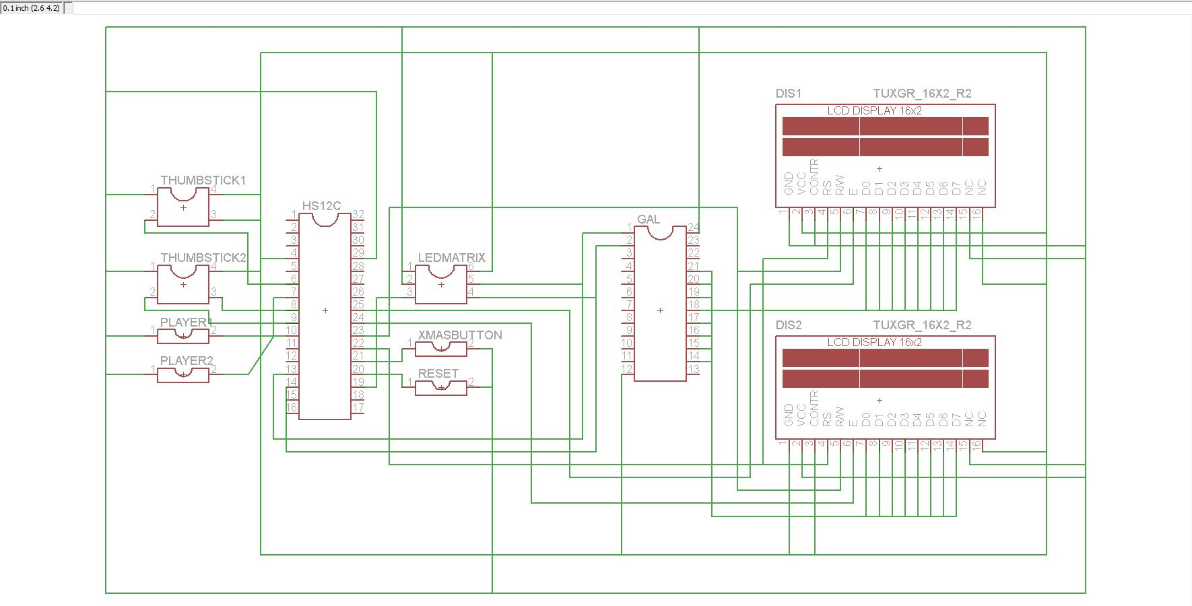

Documentation produced by Felise Goh

Appendix C:

Software Flowcharts

Include software flow diagrams and/or pseudo code here.

Be sure to clearly identify the team member(s) responsible for producing this documentation.

NOTE: Software source listing file must be submitted on-line and should NOT be included here.

Documentation produced by Felise Goh
Pseudo Code for game implementation provided by Erin Rasmussen

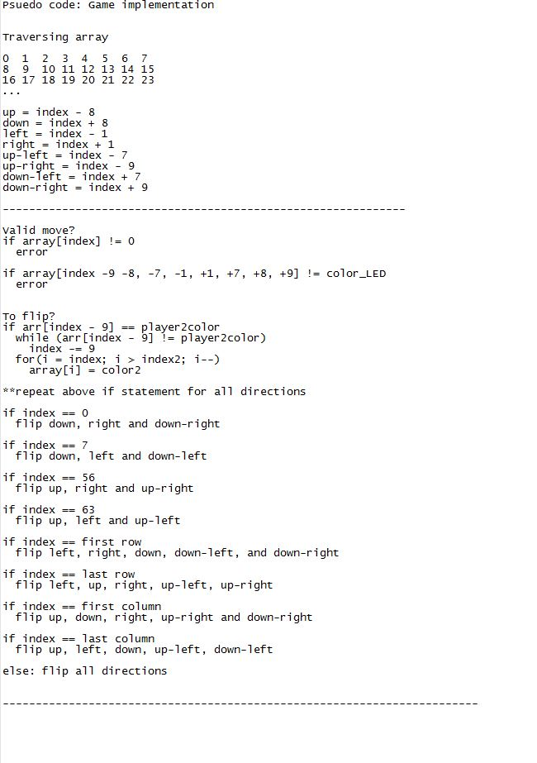

Pseudo Code for software-to-hardware implementation by Clayton Brandt

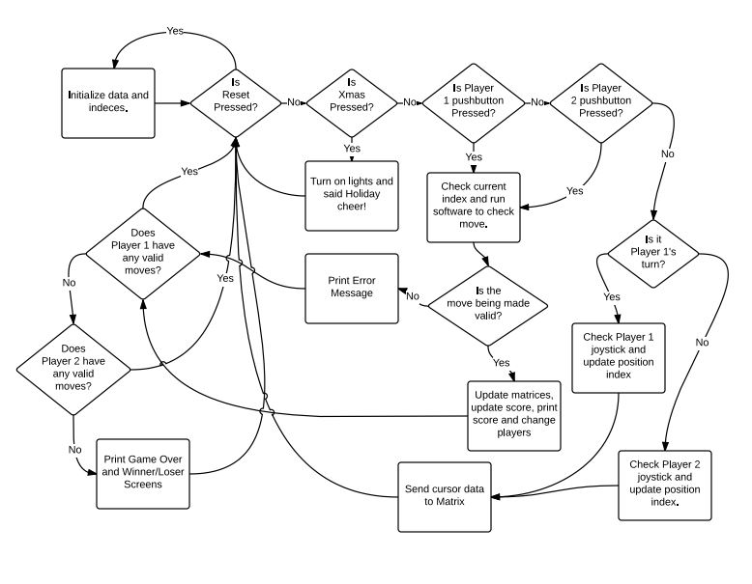

Appendix D:

Packaging Design

Paste illustrations/pictures of your project packaging here.

Be sure to clearly identify the team member(s) responsible for producing this documentation.

Pictures for project packaging by Felise Goh
Documentation produced by Felise Goh

